Automation Testing vs Manual Testing: Key Difference
- Manual Testing is done manually by QA analyst (Human) whereas Automation Testing is done with the use of script, code and automation tools (computer) by a tester.
- Manual Testing process is not accurate because of the possibilities of human errors whereas the Automation process is reliable because it is code and script based.
- Manual Testing is a time-consuming process whereas Automation Testing is very fast.
- Manual Testing is possible without programming knowledge whereas Automation Testing is not possible without programming knowledge.
- Manual Testing allows random Testing whereas Automation Testing doesn’t allow random Testing.

What is Manual Testing?
Manual testing is testing of the software where tests are executed manually by a QA Analyst. It is performed to discover bugs in software under development.
In Manual testing, the tester checks all the essential features of the given application or software. In this process, the software testers execute the test cases and generate the test reports without the help of any automation software testing tools.
It is a classical method of all testing types and helps find bugs in software systems. It is generally conducted by an experienced tester to accomplish the software testing process.
What is Automation Testing?
In Automated Software Testing, testers write code/test scripts to automate test execution. Testers use appropriate automation tools to develop the test scripts and validate the software. The goal is to complete test execution in a less amount of time.
Automated testing entirely relies on the pre-scripted test which runs automatically to compare actual result with the expected results. This helps the tester to determine whether or not an application performs as expected.
Automated testing allows you to execute repetitive task and regression test without the intervention of manual tester. Even though all processes are performed automatically, automation requires some manual effort to create initial testing scripts.
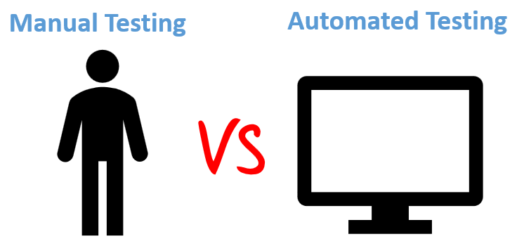
Manual Testing Vs. Automation Testing
Parameter | Automation Testing | Manual Testing
Definition | Automation Testing uses automation tools to execute test cases. | In manual testing, test cases are executed by a human tester and software.
Processing time | Automated testing is significantly faster than a manual approach. | Manual testing is time-consuming and takes up human resources.
Exploratory Testing | Automation does not allow random testing | Exploratory testing is possible in Manual Testing
Initial investment | The initial investment in the automated testing is higher. Though the ROI is better in the long run. | The initial investment in the Manual testing is comparatively lower. ROI is lower compared to Automation testing in the long run.
Reliability | Automated testing is a reliable method, as it is performed by tools and scripts. There is no testing Fatigue. | Manual testing is not as accurate because of the possibility of the human errors.
UI Change | For even a trivial change in the UI of the AUT, Automated Test Scripts need to be modified to work as expected | Small changes like change in id, class, etc. of a button wouldn’t thwart execution of a manual tester.
Investment | Investment is required for testing tools as well as automation engineers | Investment is needed for human resources.
Cost-effective | Not cost effective for low volume regression | Not cost effective for high volume regression.
Test Report Visibility | With automation testing, all stakeholders can login into the automation system and check test execution results | Manual Tests are usually recorded in an Excel or Word, and test results are not readily/ readily available.
Human observation | Automated testing does not involve human consideration. So it can never give assurance of user-friendliness and positive customer experience. | The manual testing method allows human observation, which may be useful to offer user-friendly system.
Performance Testing | Performance Tests like Load Testing, Stress Testing, Spike Testing, etc. have to be tested by an automation tool compulsorily. | Performance Testing is not feasible manually
Parallel Execution | This testing can be executed on different operating platforms in parallel and reduce test execution time. | Manual tests can be executed in parallel but would need to increase your human resource which is expensive
Batch testing | You can Batch multiple Test Scripts for nightly execution. | Manual tests cannot be batched.
Programming knowledge | Programming knowledge is a must in automation testing. | No need for programming in Manual Testing.
Set up | Automation test requires less complex test execution set up. | Manual testing needs have a more straightforward test execution setup
Engagement | Done by tools. Its accurate and never gets bored! | Repetitive Manual Test Execution can get boring and error-prone.
Ideal approach | Automation testing is useful when frequently executing the same set of test cases | Manual testing proves useful when the test case only needs to run once or twice.
Build Verification  Testing | Automation testing is useful for Build Verification  Testing (BVT). | Executing the Build Verification Testing (BVT) is very difficult and time-consuming in manual testing.
Deadlines | Automated Tests have zero risks of missing out a pre-decided test. | Manual Testing has a higher risk of missing out the pre-decided test deadline.
Framework | Automation testing uses frameworks like Data Drive, Keyword, Hybrid to accelerate the automation process. | Manual Testing does not use frameworks but may use guidelines, checklists, stringent processes to draft certain test cases.
Documentation | Automated Tests acts as a document provides training value especially for automated unit test cases. A new developer can look into a unit test cases and understand the code base quickly. | Manual Test cases provide no training value
Test Design | Automated Unit Tests enforce/drive Test Driven Development Design. | Manual Unit Tests do not drive design into the coding process
Devops | Automated Tests help in Build Verification Testing and are an integral part of DevOps Cycle | Manual Testing defeats the automated build principle of DevOps
When to Use? | Automated Testing is suited for Regression Testing, Performance Testing, Load Testing or highly repeatable functional test cases. | Manual Testing is suitable for Exploratory, Usability and Adhoc Testing. It should also be used where the AUT changes frequently.
Manual Testing Pros and Cons
Pros of Manual Testing:
- Get fast and accurate visual feedback
- It is less expensive as you don’t need to spend your budget for the automation tools and process
- Human judgment and intuition always benefit the manual element
- While testing a small change, an automation test would require coding which could be time-consuming. While you could test manually on the fly.
Cons of Manual Testing:
- Less reliable testing method because it’s conducted by a human. Therefore, it is always prone to mistakes & errors.
- The manual testing process can’t be recorded, so it is not possible to reuse the manual test.
- In this testing method, certain tasks are difficult to perform manually which may require an additional time of the software testing phase.
Automated Testing Pros and Cons
Pros of automated testing:
- Automated testing helps you to find more bugs compare to a human tester
- As most of the part of the testing process is automated, you can have a speedy and efficient process
- Automation process can be recorded. This allows you to reuse and execute the same kind of testing operations
- Automated testing is conducted using software tools, so it works without tiring and fatigue unlike humans in manual testing
- It can easily increase productivity because it provides fast & accurate testing result
- Automated testing support various applications
- Testing coverage can be increased because of automation testing tool never forget to check even the smallest unit
Cons of Automated Testing:
- Without human element, it’s difficult to get insight into visual aspects of your UI like colors, font, sizes, contrast or button sizes.
- The tools to run automation testing can be expensive, which may increase the cost of the testing project.
- Automation testing tool is not yet foolproof. Every automation tool has their limitations which reduces the scope of automation.
- Debugging the test script is another major issue in the automated testing. Test maintenance is costly.

